

PRACTICAL – 3
AIM: Implementation of max-heap sort algorithm.

Max heap sort Algorithm:
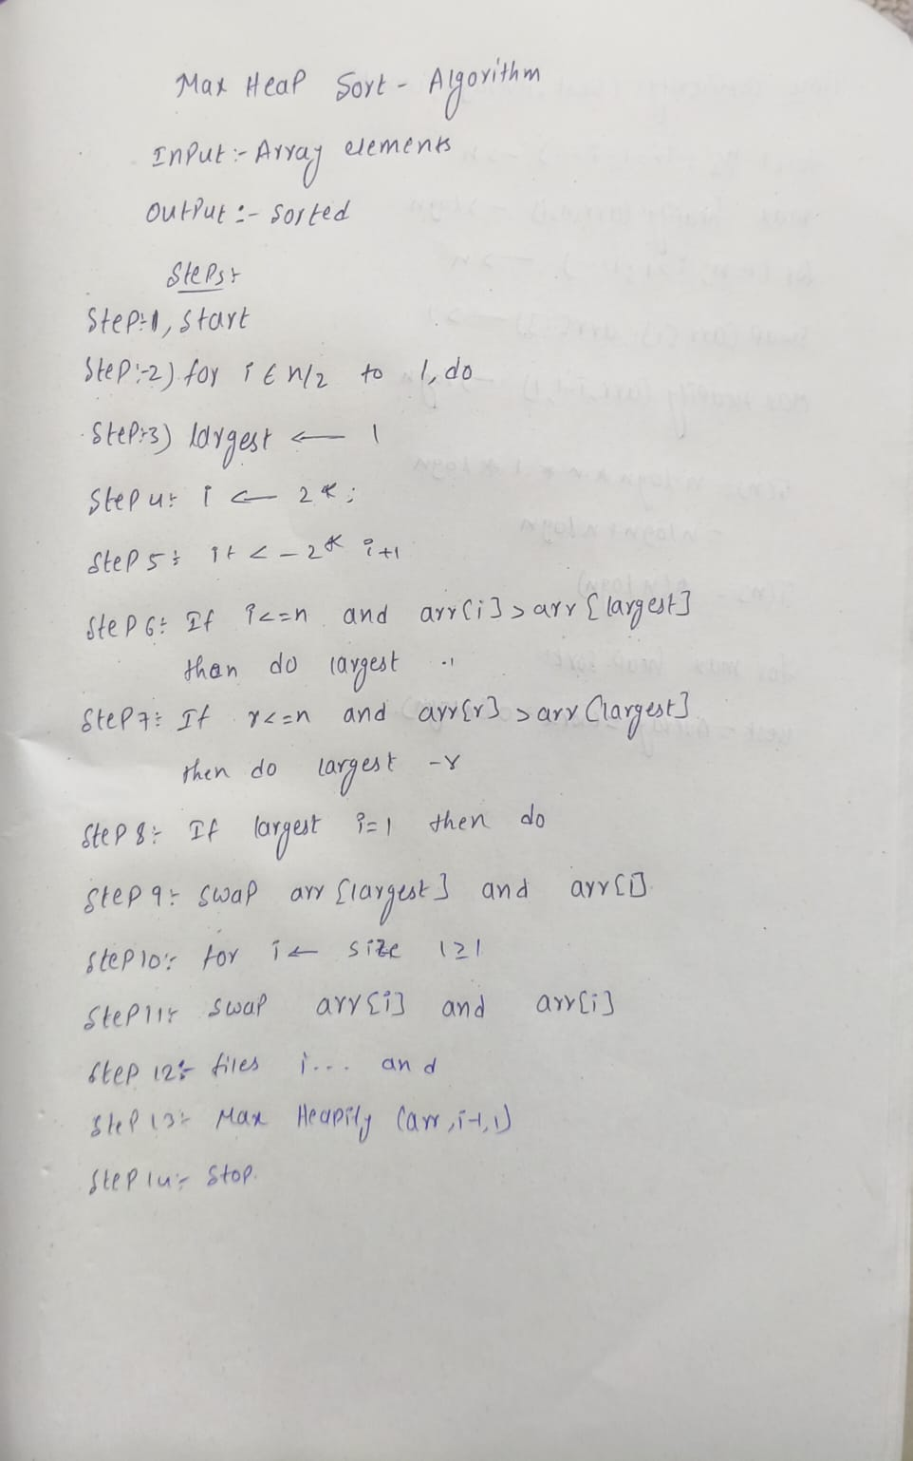

CODE:
#include<iostream> using namespacestd;void heapify(int arr[], intn,inti)
{ int largest=i;int left = 2 * i + 1; int right=2*i+2; if (left < n && arr[left]>arr[largest]) largest = left;

P.Ganesh(92400118911) 5EN-11 Batch-B



if(right<n&&arr[right]>arr[largest]) largest = right; if (largest != i)
{ swap(arr[i], arr[largest]); heapify(arr, n, largest);
} } voidheapSort(int arr[], int n)
{
// Build Max Heap for(inti=n/2-1;i>=0;i--) heapify(arr, n, i); // Heap Sort for (int i = n - 1; i >0; i--)
{ swap(arr[0], arr[i]); heapify(arr, i, 0);
} } int main() { intn; int arr[100]; cout << "Enter size of array: "; cin >>n; cout << "Enter array elements: "; for(int i = 0; i < n; i++) cin >> arr[i]; heapSort(arr, n); cout << "Sorted array: "; for(int i = 0;i
< n; i++) cout << arr[i] << " "; return0;
}

OUTPUT:
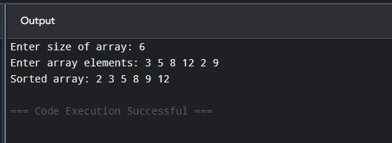

P.Ganesh (92400118911) 5EN-11 Batch-B



TIME COMPLEXITY:
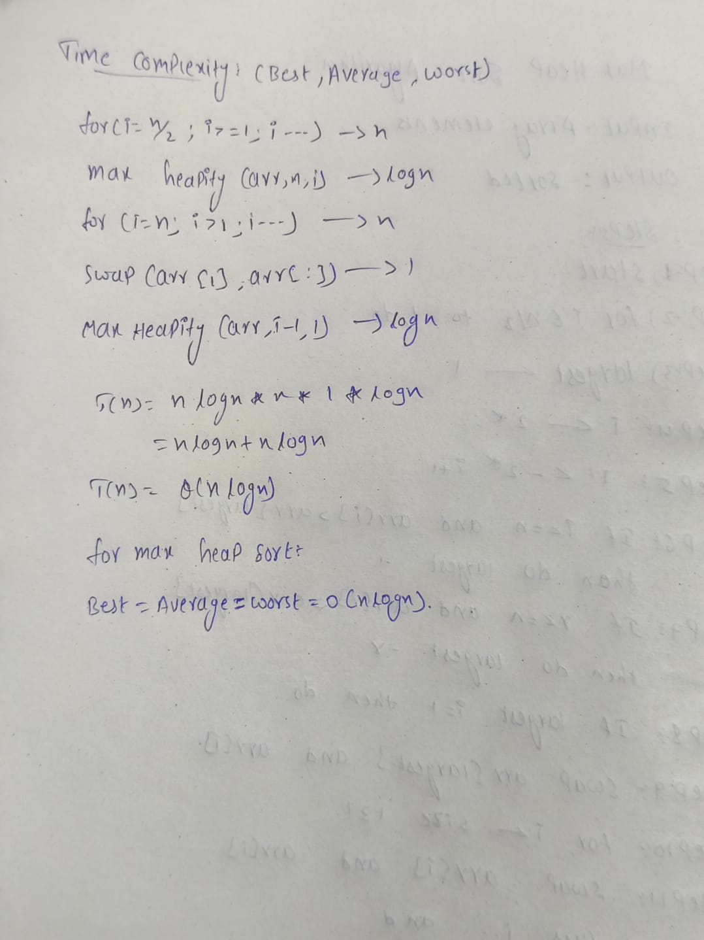

CONCLUSION:
The Max-Heap Sort algorithm was successfully implemented and tested. It works by first arranging the elements into a max-heap and then repeatedly moving the largest element to the end of the array. This process continues until all elements are sorted. Heap Sort is suitable for handling large datasets and has a time complexity of o(n log n).

P.Ganesh (92400118911) 5EN-11 Batch-B

